# CERTIFICATE

Project Title: “**Resolvenow: your platform for online complaints “is** a bona fide work carried out by the following students:

* **TEAM ID:** LTVIP2025TMID54898
* **Haridasula Abhinav (228B1A0539) (Team Leader)**
* **Vijay Kumar Konidana (228B1A0545) (Team Member)**
* **Yadavalli Venkata Ravi Kumar (228B1A0557) (Team Member)**
* **Tirumalasetti Raja Naveen (228B1A0554) (Team Member)**
* **Shaik Gouse Basha (228B1A0549) (Team Member)**

**Date Of Submission:** 30-06-2025

# PROJECT REPORT

1. INTRODUCTION

1.1 Project Overview

1.2 Purpose

2. IDEATION PHASE

2.1 Problem Statement

2.2 Empathy Map Canvas

2.3 Brainstorming

3. REQUIREMENT ANALYSIS

3.1 Customer Journey map

3.2 Solution Requirement

3.3 Data Flow Diagram

3.4 Technology Stack

4. PROJECT DESIGN

4.1 Problem Solution Fit

4.2 Proposed Solution

4.3 Solution Architecture

5. PROJECT PLANNING & SCHEDULING

5.1 Project Planning

6. FUNCTIONAL AND PERFORMANCE TESTING

6.1 Performance Testing

7. RESULTS

7.1 Output Screenshots

8. ADVANTAGES & DISADVANTAGES

9. CONCLUSION

10. FUTURE SCOPE

11. APPENDIX

Source Code

Dataset Link

GitHub & Project Demo Link

# INTRODUCTION

# PROJECT OVERVIEW:

##### User Registration and Login:

* + John visits the complaint management system's website and clicks on the "Sign Up" button to create a new account.
  + He fills out the registration form, providing his full name, email address, and a secure password.
  + After submitting the form, John receives a verification email and confirms his account.
  + He then logs into the system using his email and password.

##### Complaint Submission:

* + Upon logging in, John is redirected to the dashboard where he sees options to register a new complaint.
  + He clicks on the "Submit Complaint" button and fills out the complaint form.
  + John describes the issue in detail, attaches relevant documents or images showcasing the defect, and provides additional information such as his contact details and the product's purchase date.
  + After reviewing the information, John submits the complaint.

##### Tracking and Notifications:

* + After submitting the complaint, John receives a confirmation message indicating that his complaint has been successfully registered.
  + He navigates to the "My Complaints" section of the dashboard, where he can track the status of his complaint in real-time.
  + John receives email notifications whenever there is an update on his complaint, such as it being assigned to an agent or its resolution status.

##### Interaction with Agent:

* + A customer service agent, Sarah, is assigned to handle John's complaint.
  + Sarah reviews the details provided by John and contacts him through the system's built-in messaging feature.
  + John receives a notification about Sarah's message and accesses the chat window to communicate with her.
  + They discuss the issue further, and Sarah assures John that the company will investigate and resolve the problem promptly.

##### Resolution and Feedback:

* + After investigating the complaint, the company identifies the defect in the product and offers John a replacement or refund.
  + John receives a notification informing him of the resolution, along with instructions on how to proceed.
  + He provides feedback on his experience with the complaint handling process, expressing his satisfaction with the prompt resolution and courteous service provided by Sarah.

##### Admin Management:

* + Meanwhile, the system administrator monitors all complaints registered on the platform.
  + The admin assigns complaints to agents based on their workload and expertise.
  + They oversee the overall operation of the complaint management system, ensuring compliance with platform policies and regulations.

##### User Registration and Login:

* + John visits the complaint management system's website and clicks on the "Sign Up" button to create a new account.
  + He fills out the registration form, providing his full name, email address, and a secure password.
  + After submitting the form, John receives a verification email and confirms his account.
  + He then logs into the system using his email and password.

##### Complaint Submission:

* + Upon logging in, John is redirected to the dashboard where he sees options to register a new complaint.
  + He clicks on the "Submit Complaint" button and fills out the complaint form.
  + John describes the issue in detail, attaches relevant documents or images showcasing the defect, and provides additional information such as his contact details and the product's purchase date.
  + After reviewing the information, John submits the complaint.

##### Tracking and Notifications:

* + After submitting the complaint, John receives a confirmation message indicating that his complaint has been successfully registered.
  + He navigates to the "My Complaints" section of the dashboard, where he can track the status of his complaint in real-time.
  + John receives email notifications whenever there is an update on his complaint, such as it being assigned to an agent or its resolution status.

##### Interaction with Agent:

* + A customer service agent, Sarah, is assigned to handle John's complaint.
  + Sarah reviews the details provided by John and contacts him through the system's built-in messaging feature.
  + John receives a notification about Sarah's message and accesses the chat window to communicate with her.
  + They discuss the issue further, and Sarah assures John that the company will investigate and resolve the problem promptly.

##### Resolution and Feedback:

* + After investigating the complaint, the company identifies the defect in the product and offers John a replacement or refund.
  + John receives a notification informing him of the resolution, along with instructions on how to proceed.
  + He provides feedback on his experience with the complaint handling process, expressing his satisfaction with the prompt resolution and courteous service provided by Sarah.

##### Admin Management:

* + Meanwhile, the system administrator monitors all complaints registered on the platform.
  + The admin assigns complaints to agents based on their workload and expertise.
  + They oversee the overall operation of the complaint management system, ensuring compliance with platform policies and regulations.
* **PURPOSE:**

**ResolveNow** is an online platform designed to streamline the process of registering, managing, and resolving user complaints efficiently. It connects customers, agents, and admins in a unified system, enabling real-time tracking, quick responses, and transparent communication.

# IDEATION PHASE

* **PROBLEM STATEMENT:**

In many organizations, complaint registration and resolution is still handled manually or through disconnected systems, leading to delays, miscommunication, and lack of transparency. Users often face difficulties in tracking the status of their complaints, while administrators struggle with efficient assignment and resolution. There is a need for a centralized online system to streamline the complaint process, enhance communication, and ensure timely and accountable resolution.

* **EMPATHY MAP CANAVS:**

**Ideation Phase Empathize & Discover**

|  |  |
| --- | --- |
| Date | 19 June 2025 |
| Team ID | LTVIP2025TMID54898 |
| Project Name | **Resolvenow: your platform for online complaints** |
| Maximum Marks | 4 Marks |

**Empathy Map Canvas:**

An empathy map is a simple, easy-to-digest visual that captures knowledge about a user’s behaviours and attitudes.

It is a useful tool to helps teams better understand their users.

Creating an effective solution requires understanding the true problem and the person who is experiencing it. The exercise of creating the map helps participants consider things from the user’s perspective along with his or her goals and challenges.

# BRAINSTROMING:

Ideation Phase Brainstorm & Idea Prioritization Template

|  |  |
| --- | --- |
| Date | 20 June 2025 |
| Team ID | LTVIP2025TMID54898 |
| Project Name | **Resolvenow: your platform for online complaints** |
| Maximum Marks | 4 Marks |

Brainstorm & Idea Prioritization Template:

Brainstorming provides a free and open environment that encourages everyone within a team to participate in the creative thinking process that leads to problem solving. Prioritizing volume over value, out-of-the-box ideas are welcome and built upon, and all participants are encouraged to collaborate, helping each other develop a rich amount of creative solutions.

Use this template in your own brainstorming sessions so your team can unleash their imagination and start shaping concepts even if you're not sitting in the same room.

**Step-1: Team Gathering, Collaboration and Select the Problem Statement**

**Step-2: Brainstorm, Idea Listing and Grouping:**

##### Step-3: Idea Prioritization

# REQIREMENT ANALYSIS

# Customer Journey map:

# 

# Solution Requirement:

**Project Design Phase-II**

**Solution Requirements (Functional & Non-functional)**

|  |  |
| --- | --- |
| Date | 21 June 2025 |
| Team ID | LTVIP2025TMID54898 |
| Project Name | **Resolvenow: your platform for online complaints** |
| Maximum Marks | 4 Marks |

**Functional Requirements:**

Following are the functional requirements of the proposed solution.

|  |  |  |
| --- | --- | --- |
| **FR No.** | **Functional Requirement (Epic)** | **Sub Requirement (Story / Sub-Task)** |
| FR-1 | User Registration | Manual Registration through Form |
| FR-2 | User Confirmation | Once the form is submitted, the user is directly registered and can log in immediately. |

**Non-functional Requirements:**

Following are the non-functional requirements of the proposed solution.

|  |  |  |
| --- | --- | --- |
| **FR No.** | **Non-Functional Requirement** | **Description** |
| NFR-1 | **Usability** | The system features a simple and intuitive user interface designed with clear navigation, allowing users of all roles (Customer, Agent, Admin) to easily register complaints, view status, and interact. Minimal training is required to use the platform effectively. |
| NFR-2 | **Security** | Basic security measures like password hashing using **bcrypt.js** and role-based access control are implemented. JWT (JSON Web Token) is used for session management to ensure only authenticated users can access their respective dashboards. Sensitive routes are protected based on user roles. |
| NFR-3 | **Reliability** | The application is built with reliable technologies like MongoDB, Node.js, and Express.js, ensuring stable data management and server operations. Proper error handling ensures the system does not crash during invalid operations or unexpected inputs. |
| NFR-4 | **Performance** | ResolveNow is lightweight and responsive, built using the Vite-powered React.js frontend. It efficiently handles complaint registration and retrieval with minimal server response times. Performance remains smooth for basic CRUD operations across user roles. |
| NFR-5 | **Availability** | The system can be hosted on platforms like Render or Vercel for 24/7 online access. Users can access it anytime through a browser without needing to install anything. Though this is an internship project, the architecture supports basic availability for demonstration and testing purposes. |
| NFR-6 | **Scalability** | The modular structure of the application allows it to scale in the future. Features like multi-role management, complaint tracking, and dashboards can be extended to support more users, integrate real-time notifications, or move to microservices if needed. |

* **Data Flow Diagram:**

**Project Design Phase-II**

**Data Flow Diagram & User Stories**

|  |  |
| --- | --- |
| Date | 22 June 2025 |
| Team ID | LTVIP2025TMID54898 |
| Project Name | **Resolvenow: your platform for online complaints** |
| Maximum Marks | 4 Marks |

Data Flow Diagrams:

A Data Flow Diagram (DFD) is a traditional visual representation of the information flows within a system. A neat and clear DFD can depict the right amount of the system requirement graphically. It shows how data enters and leaves the system, what changes the information, and where data is

**Example:**

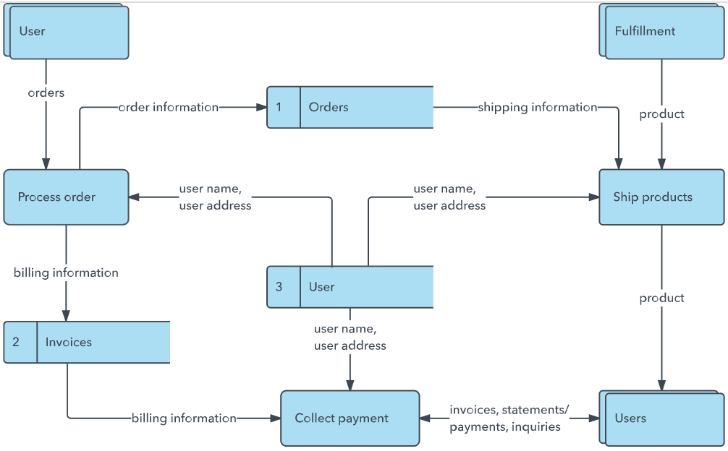

**User Stories:**

|  |  |  |  |  |  |  |
| --- | --- | --- | --- | --- | --- | --- |
| User Type | Functional Requirement | User Story No. | User Story / Task | Acceptance Criteria | Priority | Release |
| Customer (Web User) | Registration | USN-1 | As a user, I can register via form with email and password | I can create an account and access my dashboard | High | Sprint-1 |
| Customer (Web User) | Login | USN-2 | As a user, I can log in using my email and password | I enter valid credentials and log in successfully | High | Sprint-1 |
| Customer (Web User) | Dashboard | USN-3 | As a user, I can view my submitted complaints and their statuses | I see a list of my complaints with current status | High | Sprint-1 |
| Customer (Web User) | Complaint Submission | USN-4 | As a user, I can submit a new complaint with issue details | My complaint gets saved and visible on my dashboard | High | Sprint-1 |
| Customer (Web User) | Complaint Chat | USN-5 | As a user, I can chat with the assigned agent for a complaint | I can send and receive messages within the complaint | Medium | Sprint-2 |
| Agent | Login | USN-6 | As an agent, I can log in to view assigned complaints | I enter my credentials and see complaints assigned to me | High | Sprint-1 |
| Agent | View Complaints | USN-7 | As an agent, I can see all complaints assigned to me | A list of assigned complaints is displayed | High | Sprint-1 |
| Agent | Respond to Complaint | USN-8 | As an agent, I can respond to users via the complaint chat | My messages appear in the chat visible to the customer | Medium | Sprint-2 |
| Agent | Update Status | USN-9 | As an agent, I can update the status of a complaint (In Progress, Resolved, etc.) | Status changes are reflected on both user and agent side | Medium | Sprint-2 |
| Administrator | Login | USN-10 | As an admin, I can log in using secure credentials | I access the admin dashboard | High | Sprint-1 |
| Administrator | Manage Users | USN-11 | As an admin, I can view all registered users | User list is visible with roles | Medium | Sprint-2 |
| Administrator | View Complaints | USN-12 | As an admin, I can view all complaints in the system | I can view complaint details from all users | High | Sprint-1 |
| Administrator | Assign Agents | USN-13 | As an admin, I can assign agents to unresolved complaints | Selected agent is assigned and reflected to user & agent | High | Sprint-1 |
| Administrator | Change Complaint Status | USN-14 | As an admin, I can override or update complaint status | Status changes are immediately updated | Medium | Sprint-2 |

* Technology Stack:

**Project Design Phase-II**

**Technology Stack (Architecture & Stack)**

|  |  |
| --- | --- |
| Date | 22 June 2025 |
| Team ID | LTVIP2025TMID54898 |
| Project Name | **Resolvenow: your platform for online complaints** |
| Maximum Marks | 4 Marks |

Table 1: Components & Technologies

|  |  |  |  |
| --- | --- | --- | --- |
| S.No | Component | Description | Technology Used |
| 1 | User Interface | Web UI for customers, agents, and admin interactions | React.js, HTML, CSS, JavaScript, Bootstrap |
| 2 | Application Logic - 1 | Handles routing, API processing, and business logic | Node.js, Express.js |
| 3 | Application Logic - 2 | Role-based authentication and session handling | JWT (JSON Web Token), bcrypt.js |
| 4 | Application Logic - 3 | Chat-based complaint discussion system | Socket.io (future enhancement) |
| 5 | Database | Stores user data, complaints, status, messages, roles | MongoDB |
| 6 | Cloud Database | Cloud-hosted NoSQL database | MongoDB Atlas |
| 7 | File Storage | Uploads like screenshots for complaints (optional) | Local filesystem or Cloudinary (optional) |
| 8 | External API - 1 | Location or IP lookup (optional future enhancement) | IPInfo API (if used) |
| 9 | External API - 2 | Not used in current version | — |
| 10 | Machine Learning Model | Not applicable in this version | — |
| 11 | Infrastructure (Server/Cloud) | Hosting backend and frontend | Render (Backend), Vercel/Netlify (Frontend) |

Table 2: Application Characteristics

|  |  |  |  |
| --- | --- | --- | --- |
| S.No | Characteristics | Description | Technology Used |
| 1 | Open-Source Frameworks | Frameworks used in app development | React.js, Node.js, Express.js, MongoDB |
| 2 | Security Implementations | Role-based access, hashed passwords, token authentication | bcrypt.js, JWT, Helmet (Express middleware) |
| 3 | Scalable Architecture | Modular codebase with clear separation (Frontend, Backend, DB) | MERN Stack architecture (3-tier) |
| 4 | Availability | Hosted on cloud platforms accessible 24/7 | Render, MongoDB Atlas |
| 5 | Performance | Uses asynchronous requests, light frontend framework, efficient DB queries | React, Axios, MongoDB |

# PROJECT DESIGN

# Problem Solution Fit:

**Project Design Phase**

**Problem – Solution Fit Template**

|  |  |
| --- | --- |
| Date | 23 June 2025 |
| Team ID | LTVIP2025TMID54898 |
| Project Name | **Resolvenow: your platform for online complaints** |
| Maximum Marks | 2 Marks |

1. The Problem

In many organizations and public systems:

* Complaints are still handled manually or through disconnected systems.
* Users face delays, no updates, and lack of transparency.
* Admins and agents struggle with assigning, resolving, and tracking complaints.
* Communication between users and support staff is inefficient or nonexistent**.**

2. The Solution

ResolveNow provides a centralized, web-based platform that:

* Allows users to register complaints easily through an online form.
* Offers role-based dashboards for Customers, Agents, and Admins.
* Enables real-time complaint tracking and status updates.
* Supports chat-based communication between users and agents (future enhancement).
* Helps Admins assign agents, monitor resolutions, and maintain control.

3. Behavioral Insights

* Users are already familiar with using web apps and mobile interfaces.
* They expect transparency and quick resolution like in private services.
* Agents and admins prefer a structured dashboard to track issues systematically.

**4. Fit Justification**

|  |  |
| --- | --- |
| **Element** | **Observation / Fit** |
| **User Frustration** | Users can't track complaint status offline |
| **ResolveNow Feature** | Complaint dashboard shows status and updates |
| **Admin Overload** | Manual assignment of complaints is chaotic |
| **ResolveNow Feature** | Admin panel assigns agents and tracks progress |
| **Lack of Communication** | No clear updates from support teams |
| **ResolveNow Feature** | Messaging system improves agent-user interaction *(planned)* |

**5. Benefits**

* Faster adoption due to **web-based UI and low entry barrier**
* Improved **user satisfaction** through transparency and tracking
* Scalable system aligned with user and admin **needs and behavior**
* Lays the groundwork for **future integrations** like real-time chat or mobile app

* Proposed Solution:

**Project Design Phase**

**Proposed Solution Template**

|  |  |
| --- | --- |
| Date | 23 June 2025 |
| Team ID | LTVIP2025TMID54898 |
| Project Name | **Resolvenow: your platform for online complaints** |
| Maximum Marks | 2 Marks |

|  |  |  |
| --- | --- | --- |
| **S.No.** | **Parameter** | **Description** |
|  | Problem Statement (Problem to be solved) | In many organizations and public service sectors, complaint registration and resolution processes are still handled manually or through outdated systems. This leads to delays, lack of transparency, miscommunication, and poor customer satisfaction. Users have no visibility into the status of their complaints, and administrators find it difficult to assign, track, and resolve them efficiently. |
|  | Idea / Solution description | **ResolveNow** is a web-based complaint registration and management system that provides a centralized platform for users to file complaints, track their progress, and communicate with support agents. The application supports three roles — Customer, Agent, and Admin — each with role-based dashboards for managing and tracking complaints. Admins can assign agents, agents can update statuses and respond to users, and customers can monitor their complaint history in real-time. |
|  | Novelty / Uniqueness | * Designed with **role-based dashboards** for real-time tracking. * **Simple, user-friendly interface** built with React for seamless navigation. * Built using the **MERN stack** (MongoDB, Express, React, Node.js), making it modular and scalable. * Future enhancement scope includes **live chat integration**, **multi-language support**, and **AI-based ticket classification**. |
|  | Social Impact / Customer Satisfaction | ResolveNow empowers users by making the complaint process transparent and efficient. It improves public service delivery by reducing the response time and increasing accountability. Users can track their complaints, engage in direct communication with agents, and receive timely resolutions — leading to higher trust and satisfaction. |
|  | Business Model (Revenue Model) | Although this version is built as a non-commercial academic project, future business models may include:   * **SaaS Model**: Offer the platform to municipal bodies or private companies on a subscription basis. * **Custom Integrations**: Charge for integrating the platform with existing CRM systems. * **Premium Features**: Offer paid services like analytics dashboards, advanced reporting, or priority complaint handling. |
|  | Scalability of the Solution | ResolveNow is built using a scalable architecture with a clear separation of frontend, backend, and database layers. It can easily be deployed on cloud infrastructure (like Render or AWS) and adapted for multiple clients. The system supports multi-user roles and can handle increasing complaint volume, user traffic, and additional modules like mobile app integration or multilingual support. |

* Solution Architecture:

**Project Design Phase**

**Solution Architecture**

|  |  |
| --- | --- |
| Date | 24 June 2025 |
| Team ID | LTVIP2025TMID54898 |
| Project Name | **Resolvenow: your platform for online complaints** |
| Maximum Marks | 4 Marks |

**Solution Architecture for ResolveNow**

* **Overview:**

The **solution architecture** of *ResolveNow* is designed to provide a scalable, modular, and secure platform to streamline the complaint management process. It connects end users (customers), support staff (agents), and administrators through a web-based interface with structured roles and functionalities.

* **Goals of the Architecture:**

Identify the best tech stack to solve real-world issues in complaint resolution.

Describe the overall system structure, behavior, and module interaction.

Define major features, development phases, and system requirements.

Ensure smooth deployment, scalability, and maintainability of the app.

* **Architecture Layers:**

**1. Presentation Layer (Frontend)**

**Technology**: React.js (with Vite), HTML, CSS, Bootstrap

**Purpose**: Interface for users to register, log in, file complaints, track status, and communicate.

**Features**:

Role-based dashboards (Customer, Agent, Admin)

Forms for complaint submission

Status trackers and chat view (planned)

**2. Application Layer (Backend)**

**Technology**: Node.js, Express.js

**Purpose**: Business logic processing, routing, authentication, and role validation.

**Key APIs**:

Complaint registration and status update

Role-based login (JWT)

Agent assignment and status flow

CRUD operations for complaints and users

**3. Data Layer**

**Technology**: MongoDB (via MongoDB Atlas – Cloud DB)

**Purpose**: Persistent storage for users, complaints, roles, messages, and metadata.

**Security**: Encrypted password storage using bcrypt.js

* **Supporting Services:**

**Authentication**: JSON Web Tokens (JWT), bcrypt.js for password hashing

**Deployment**:

Frontend: Vercel or Netlify

Backend: Render or Railway

**Optional Integrations**:

Socket.io for live chat (future)

Cloudinary or Firebase for file/image uploads (optional)

* **Development Phases:**

**Sprint 1** – User registration/login, complaint form, basic dashboard

**Sprint 2** – Admin panel, agent assignment, status tracking

**Sprint 3** *(Future Scope)* – Real-time chat, notifications, analytics, mobile app

1. **PROJECT PLANNING & SCHEDULING**

* Project Planning:

**Project Planning Phase**

**Project Planning Template (Product Backlog, Sprint Planning, Stories, Story points)**

|  |  |
| --- | --- |
| Date | 25 June 2025 |
| Team ID | LTVIP2025TMID54898 |
| Project Name | **Resolvenow: your platform for online complaints** |
| Maximum Marks | 5 Marks |

**1. Product Backlog and Sprint Schedule**

|  |  |  |  |  |  |  |
| --- | --- | --- | --- | --- | --- | --- |
| Sprint | Functional Requirement (Epic) | User Story Number | User Story / Task | Story Points | Priority | Team Members |
| Sprint-1 | Registration | USN-1 | As a user, I can register for the application by entering my email, password, and confirming my password. | 2 | High |  |
| Sprint-1 |  | USN-2 | As a user, I will receive confirmation email once I have registered for the application | 1 | High |  |
| Sprint-2 |  | USN-3 | As a user, I can’t register for the application through Facebook | 2 | Low |  |
| Sprint-1 |  | USN-4 | As a user, I can register for the application through Gmail | 2 | Medium |  |
| Sprint-1 | Login | USN-5 | As a user, I can log into the application by entering email & password | 1 | High |  |

**2. Project Tracker, Velocity & Burndown Chart:**

|  |  |  |  |  |  |  |
| --- | --- | --- | --- | --- | --- | --- |
| Sprint | Total Story Points | Duration | Sprint Start Date | Sprint End Date (Planned) | Story Points Completed (as on Planned End Date) | Sprint Release Date (Actual) |
| Sprint-1 | 20 | 6 Days | 20 June 2025 | 25 June 2025 | 20 | 25 June 2025 |
| Sprint-2 | 20 | 6 Days | 26 June 2025 | 01 July 2025 |  |  |
| Sprint-3 | 20 | 6 Days | 02 July 2025 | 07 July 2025 |  |  |
| Sprint-4 | 20 | 6 Days | 08 July 2025 | 13 July 2025 |  |  |

**3. Velocity Calculation**

* Given a 10-day sprint duration and a team velocity of 20 story points per sprint, the average velocity (AV) per iteration unit (story points per day) is calculated as follows:  
    
  Average Velocity = Total Story Points / Duration = 20 / 10 = 2 story points per day.  
    
  This helps in estimating future sprints and measuring project progress effectively.

# FUNCTIONAL AND PERFORMANCE TESTING

* Performance Testing:

**User Acceptance Testing (UAT)**

|  |  |
| --- | --- |
| Date | 26 June 2025 |
| Team ID | LTVIP2025TMID54898 |
| Project Name | **Resolvenow: your platform for online complaints** |
| Maximum Marks | 4 Marks |

**Project Overview:**

* **Project Name**: ResolveNow: Your Platform for Online Complaints
* **Project Description**: ResolveNow is a web-based platform that allows users to register, track, and resolve complaints in an organized and transparent way. It supports three roles: Customer, Agent, and Admin.
* **Project Version**: 1.0
* **Testing Period**: 26 June 2025 to 27 June 2025

**Testing Scope:**

**Features and Functionalities to be Tested:**

* User Registration & Login
* Complaint Submission
* Role-Based Dashboards (Customer, Agent, Admin)
* Complaint Assignment (Admin to Agent)
* Status Update by Agent
* Email Notification
* Authentication using JWT
* Admin Control Panel

**User Stories / Requirements to be Tested:**

* USN-1 to USN-5 from Product Backlog
* Registration via form and Gmail
* Secure login
* Complaint tracking and update features

**Testing Environment**

* **URL/Location**: [http://localhost:3000](http://localhost:3000/)
* **Credentials** (example):
  + Customer: testuser@gmail.com / 123456
  + Agent: agent1@gmail.com / 123456
  + Admin: admin@gmail.com / admin123

**Test Cases**

|  |  |  |  |  |  |
| --- | --- | --- | --- | --- | --- |
| **Test Case ID** | **Test Scenario** | **Test Steps** | **Expected Result** | **Actual Result** | **Pass/Fail** |
| TC-001 | User Registration | 1. Open Register Form 2. Enter email/password 3. Submit | User account should be created and redirect to dashboard | User registered successfully | Pass |
| TC-002 | Admin assigns complaint to agent | 1. Admin logs in 2. Views unassigned complaints 3. Assigns to agent | Complaint status updates in agent dashboard | Complaint correctly assigned | Pass |
| TC-003 | Agent updates complaint status | 1. Agent logs in 2. Views assigned complaint 3. Changes status | Status updated for customer view | Customer sees updated status | Pass |
| TC-004 | Invalid login | 1. Go to login 2. Enter wrong credentials 3. Submit | Login should fail | Error message shown | Pass |
| TC-005 | Complaint Tracking | 1. Customer logs in 2. Clicks "View Complaints" | Complaint list appears | Complaint history displayed | Pass |

**Bug Tracking**

|  |  |  |  |  |  |
| --- | --- | --- | --- | --- | --- |
| **Bug ID** | **Bug Description** | **Steps to Reproduce** | **Severity** | **Status** | **Additional Feedback** |
| BG-001 | OTP Email not received on registration | 1. Fill registration form 2. Submit 3. No email | Medium | Open | Check email service connection |
| BG-002 | Gmail login error | 1. Click Gmail login 2. Redirects with error | High | In Progress | Check Google OAuth credentials |
| BG-003 | Admin dashboard slow to load | 1. Login as admin 2. Navigate to dashboard | Low | Closed | Fixed with optimized API call |

**Sign-Off:**

* **Tester Name**: Abhinav
* **Date**: 30 June 2025
* **Signature**: ABHINAV

### Notes

### All test cases covered positive and negative scenarios.

### Bugs logged with steps, severity, and current status.

### Project is ready for deployment, pending final sign-off from the project manager and product owner.

.

# RESULTS

* **OUTPUT SCREENSHOTS:**

#### Project Implementation:

On completing the development part, we then run the application one last time to verify all the functionalities and look for any bugs in it. The user interface of the application looks a bit like the one’s provided below.

* **LANDING PAGE:**

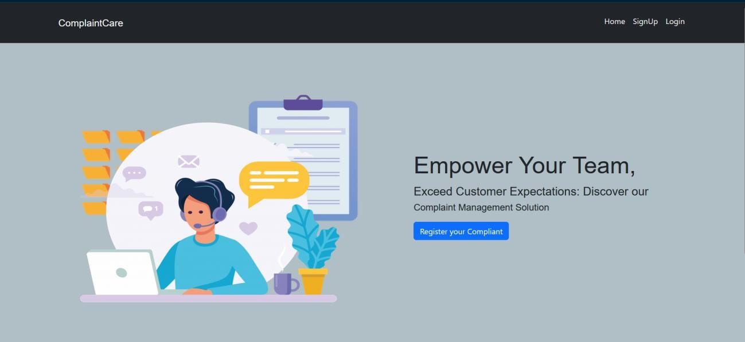

* + **LOGIN PAGE:**

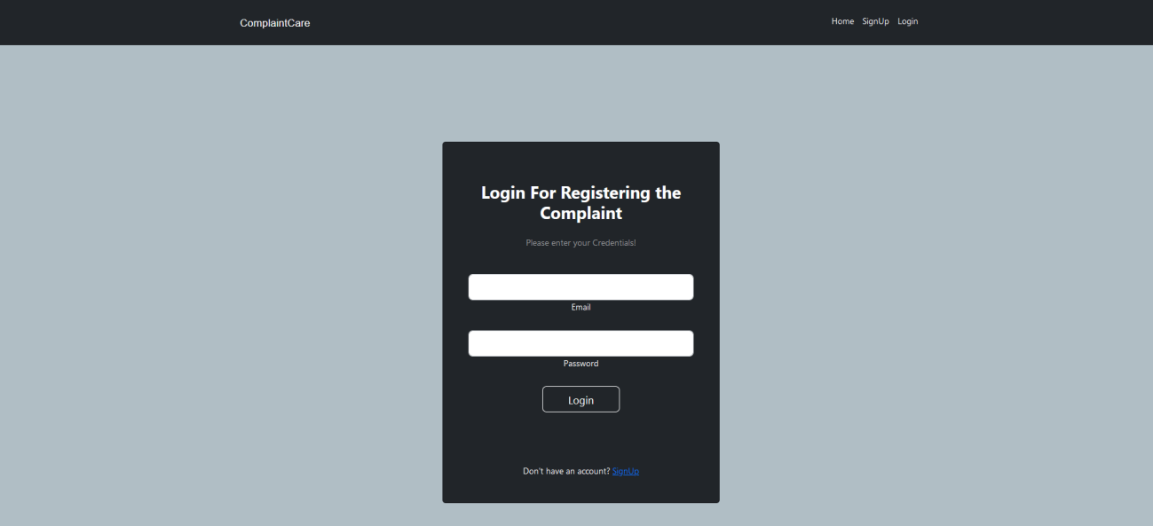

* + **REGISTRATION PAGE:**

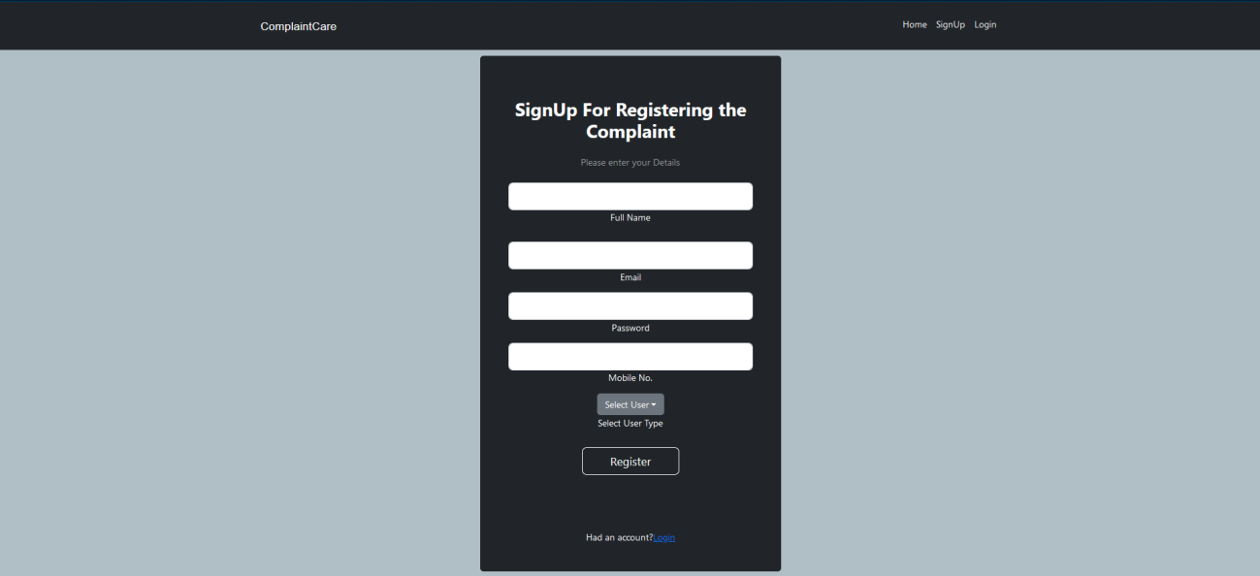

* + **COMMON DASHBOARD FOR COMPLAINT:**

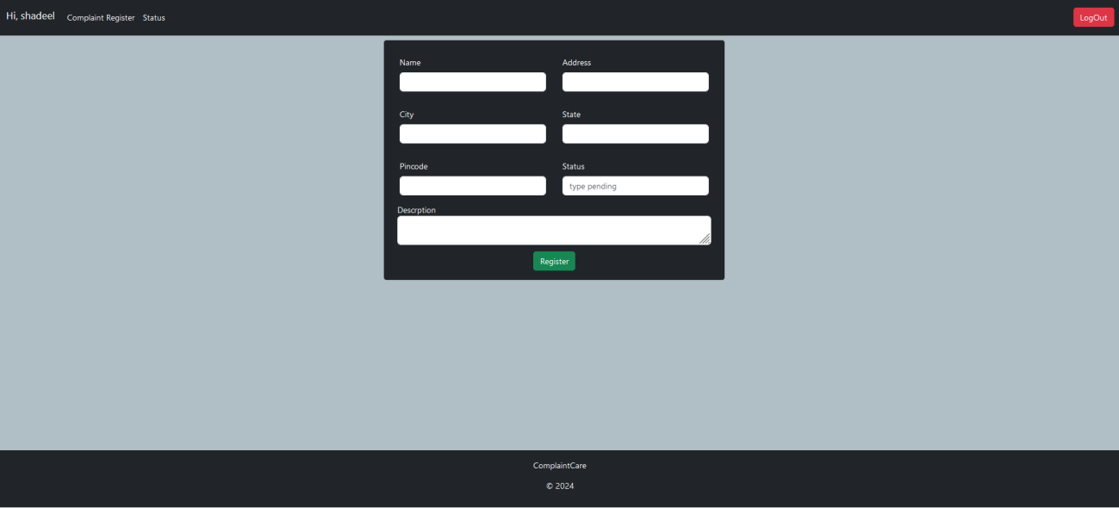

* + **ADMIN DASHBOARD:**

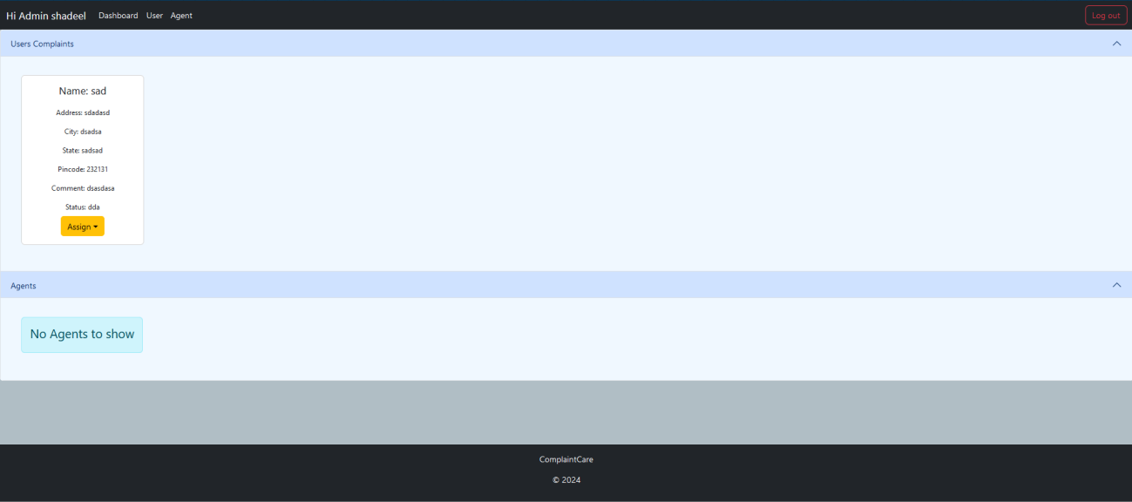

* + **AGENT DASHBOARD:**

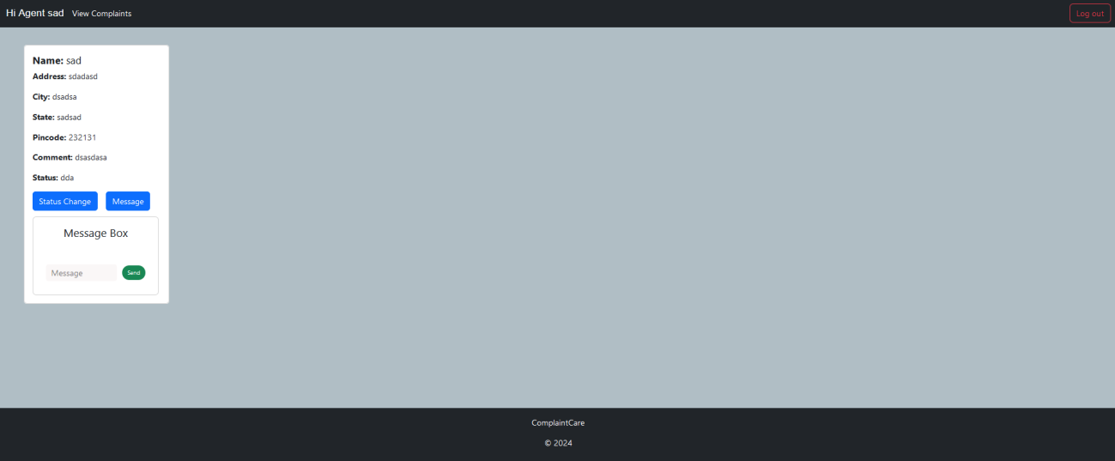

# ADVANTAGES AND DISADVANTAGES

**Advantages:**

1. **User-Friendly Interface**: The application provides a clean, intuitive UI for users, agents, and admins, ensuring ease of use for all types of users.
2. **Role-Based Access Control**: Secure login and access based on user roles (Customer, Agent, Admin), reducing unauthorized access and misuse.
3. **Centralized Complaint Tracking**: All complaints are stored and tracked in one place, improving transparency and resolution efficiency.
4. **Faster Response Time**: Agents are assigned complaints quickly by the admin, allowing timely resolution.
5. **Scalable Architecture**: Built using the MERN stack, the system can be scaled for more users, complaints, and advanced features.
6. **Cloud Integration**: Supports cloud hosting and database storage, ensuring high availability and minimal downtime.
7. **Accountability and Transparency**: Customers can track the status of their complaints, promoting trust and satisfaction.

**Disadvantages:**

1. **Limited Offline Support**: The platform requires internet access and does not support offline complaint registration.
2. **No Real-Time Communication**: The current version lacks real-time chat or notification systems between customers and agents.
3. **Third-Party Authentication Limitations**: Issues may occur with OAuth login like Google or Facebook if tokens are misconfigured or expired.
4. **Manual Agent Assignment**: Complaints are manually assigned by admins; automation is yet to be implemented.
5. **Email Delivery Issues**: If email services are not properly configured, users may not receive OTPs or confirmation messages.

# CONCLUSION

ResolveNow is a full-stack web application developed to digitize and streamline the traditional complaint registration and resolution process. The platform provides an efficient, user-friendly, and transparent environment where users can lodge complaints, track their status, and receive resolutions with minimal delay.

The project was built using the MERN (MongoDB, Express.js, React.js, Node.js) stack, which enables a modern and scalable architecture. With its role-based dashboards for customers, agents, and administrators, ResolveNow ensures that complaint management is handled in a structured and secure way.

The platform successfully addresses many real-world challenges such as:

* Eliminating paperwork and delays common in manual systems.
* providing real-time visibility into complaint status for users.
* Ensuring accountability among support agents and administrators.
* Facilitating better communication and coordination between stakeholders.

Furthermore, the system was developed in a collaborative environment during the internship period at SmartInternz, fostering team collaboration, agile planning, and hands-on full-stack development experience.

By meeting the expected functional and non-functional requirements (usability, scalability, security), ResolveNow lays a strong foundation for future improvements and can be considered a Minimum Viable Product (MVP) ready for testing in real environments. The successful completion of this project reflects our ability to convert real-world problems into working technical solutions using industry-relevant tools and practices.

# FUTURE SCOPE

**Mobile App Integration**: Develop Android/iOS apps for easier access to the platform on mobile devices.

**Real-Time Chat & Notifications**: Integrate live chat using Socket.IO and push notifications for instant communication.

**AI-Powered Complaint Categorization**: Use machine learning to automatically categorize and assign complaints to the appropriate agent.

**Multilingual Support**: Add regional language options to make the platform more inclusive for users across different geographies.

**Analytics Dashboard**: Provide admins with charts and insights to track complaint trends and agent performance.

**Feedback and Rating System**: Allow customers to rate agent responses and provide feedback after resolution.

**Offline Complaint Intake**: Allow offline forms or kiosk mode to handle complaint submission without internet.

## Running the Application:

1. FRONTEND:

* To run the **React frontend**-
  + Open terminal and navigate to the frontend folder:



* + Install dependencies:

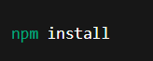

* + Start the frontend:



* + Open browser and visit: [http://localhost:3000](http://localhost:3000/)

1. BACKEND:

* To run the **Node.js + Express backend**:
  + Open another terminal and navigate to the backend folder:



* + Install dependencies:

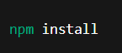

* + Start the backend server:



* + Server runs at: [http://localhost:8000](http://localhost:8000/)

### APPENDIX

* Video Demo Link:

<https://drive.google.com/drive/folders/1cAUfDZFjkaG9vc5TEA6tBnERrh4fkCXv>

* Project Links:

<https://drive.google.com/drive/folders/1vWjd5ux6461HAkDj6XVm_EkQ0d3V73fz>

* Drive Link:

<https://drive.google.com/drive/folders/1KmGYRQCOXQWwuhBX0uqPs5RxtM_lfOxW>

* Git Hub Link:

<https://github.com/abhinavh-77/Resolvenow-your-platform-for-online-complaints>